Direction from Q1 to Q5: Answer the questions given as per details given in the graph, which provides the consumption of metal and plastic across 6 years.
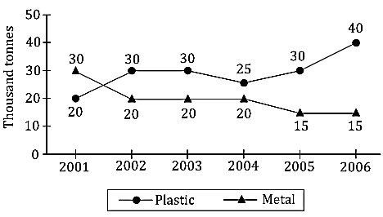
1.What is the number of years for which the consumption of metal was less than the consumption of plastic over the given period?
(a) 4 (b) 2 (c) 3 (d) 5
2.For how many years has the consumption of metal and plastic put together showed a decrease over the previous year’s consumption?
(a) 2 (b) 1 (c) 3 (d) 4
3. What is the ratio of the total consumption of metal to that of plastic in the given period?
(a) 4:5 (b) 18:23 (c) 19:23 (d) 24:35
4.What is the percentage increase in the total consumption of the products in 2006, over that in 2005?
(a) 33 1/3% (b) 22 2/9% (c) 16 2/3% (d) 37.5%
5. During which period did the consumption of both the products, shows a similar trend (both increasing / decreasing / constant)?
(a) 2003–04 (b) 2002–03 (c) 2001–02 (d) 2005–06
Direction from Q6 to Q10: Study the following graph carefully and answer the questions given below it.
Production and sale of printers of various companies in a month.
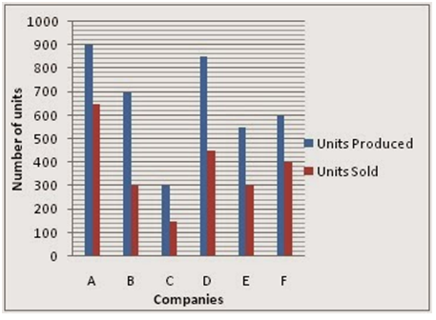
6. What is the average number of units sold by all the companies together?
(a) 360 (b) 390 (c) 375 (d) 410
7. Which company had the highest percentage of sale with respect to its production?
(a) D (b) B (c) E (d) A
8. What is the average number of units produced by all the companies together?
(a) 675 (b) 650 (c) 625 (d) 600
9. The total units sold by the companies A, B and C together is approximately what per cent of the total units produced by these companies?
(a) 62 (b) 50 (c) 76 (d) 58
10. What is the ratio of the total production of companies D and E to the total sale of the same companies?
(a) 28:15 (b) 9:5 (c) 15:11 (d) 2:3
Direction from Q11 to Q15: Table shown below shows population of five different cities. Some data is given in percent while some data is given in numbers. Study the table carefully and solve the following questions.
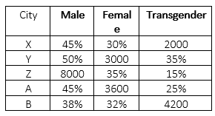
Note: Total population = Male + Female + Transgender
11. Population of city Z is what percent less than population of city Y.
(a) 30% (b) 25% (c) 20% (d) 35%
12. Ratio of literate male to Illiterate male of city A is 11 : 7. What is the difference between literate male and Illiterate male of city A.
(a) 1200 (b) 900 (c) 1400 (d) 800
13. Female population in city Z is how much percent less than male and transgender population of city A.
(a) 25% (b) 33(1/3)% (c) 50% (d) 66(2/3)%
14. Male population of city B is how much more than female population of city X?
(a) 2900 (b) 2800 (c) 2820 (d) 2920
15. Find the ratio of transgender population of city Z to the transgender population of city A.
(a) 4/5 (b) 2/5 (c) 3/5 (d) 5/4
Directions for Q16 to Q20: Answer the questions based on the information given below.
The given pie chart shows the percentage distribution of number of different types of chocolates distributed by Akshay.
Total number of chocolates distributed = 240
Percentage distribution of the types of chocolates distributed
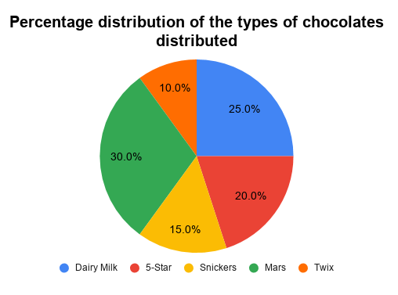
16. The average number of chocolates of Dairy Milk, 5-star and Mars taken together is equal to number of chocolates distributed of which of the given type?
(a) 5-Star (b) Snickers (c) Mars (d) Dairy milk
17. Find the ratio of number of chocolates of 5-Star and Mars taken together to the number of chocolates of Dairy milk and Twix taken together.
(a) 10:7 (b) 7:5 (c) 5:4 (d) 4:3
18. The number of chocolates of Mars distributed by Akshay is what percentage more or less than the number of chocolates of 5-Star distributed by Akshay?
(a) 20% (b) 25% (c) 30% (d) 50%
Directions for Q19 to Q23: Study the following graph and the table and answer the questions given below.
Data of different states regarding population of states in
the year 2012
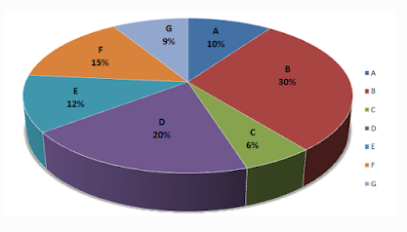
Total population of the given states = 2000000.
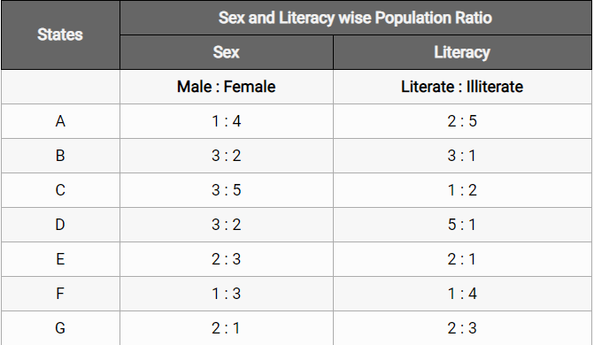
19. What was the total number of illiterate people in B state and C state in 2012?
(a) 225000 (b) 150000 (c) 230000 (d) 330000
20. What was the number of males in D state in the year 2012?
(a) 220000 (b) 120000 (c) 260000 (d) 240000
21. In the year 2013, there was an increase of 12% in the population of F state and 10% in the population of E state compared to 2012, what was the ratio of F state and E state in 2013?
(a) 14:11 (b) 11:10 (c) 13:14 (d) 15:13
22. What is the ratio of the number of females in G states to the number of females in B state?
(a) 2:3 (b) 1:3 (c) 1:4 (d) 2:5
23. What will be the percentage of the total number of males in states A, C and E together to the total population of all the given states?
(a) 9.05% (b) 10.3% (c) 6.67% (d) 7.49%

